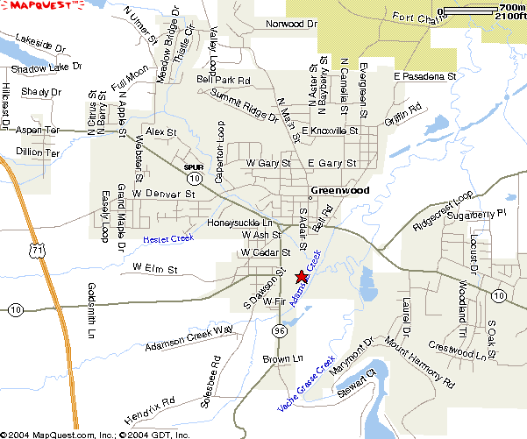

Multi-Use Trail  Paved Shoulder 

Bike Lane  Wide Outside Lane 

Bike “Peddle and Ride” 

